Be Cool
Joni Mitchell

G
If there's one rule to this game everybody's gonna name
It's be cool
C C7
If you're worried or uncertain if your feelings are hurtin'
G
You're a fool if you can't keep cool
A
Charm them, don't alarm them, keep things light
Keep your worries out of sight
C
And play it cool play it cool
C7 G
Fifty-fifty fire and ice

G
If your heart is on the floor
Cause lover's at the door with a new fool
Be cool
C7
Don't you sweat it, start tryin’ to forget it
G
Be cool
A
Don’t get riled, smile, keep it light
Be your own best friend tonight
C
Play it cool play it cool
C7 G
Fifty-fifty fire and ice

C7
Don't get jealous, don't get over-zealous
G
Keep your cool
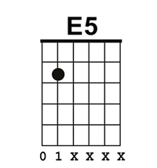
C7
Don't whine
D
Kiss off that flaky valentine
E
You're nobody's fool

G
So if there's one rule to this game everybody's gonna name
It's be cool
C C7
If you're worried or uncertain if your feelings are hurtin'
G
You're a fool if you can't keep cool
A
Charm them, don't alarm them
Keep things light
Keep your worries out of sight
C
Play it cool play it cool
C7 G
Fifty-fifty fire and ice
C
Play it cool play it cool
C7 G
Fifty-fifty fire and ice
C
Play it cool play it cool
C7 G
Fifty-fifty fire and ice

