Bitter Creek (Bernie Leadon) The Eagles capo 1
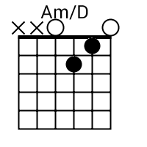
Dm Am/D G
Once I was young and so unsure
Dm Am/D G A
I'd try any ill to find the cure
Bm G
An old man told me
Bm E
Tried to scold me
Dm Am/D G A (G) F Dm Am/D G
Whoa son, don't wade too deep in Bitter Creek
------------------

Dm Am/D G
Out where the desert meets the sky
Dm Am/D G A
it's where I go when I wanna hide
Bm G
Oh peyote
Bm E
Tried to show me
Dm Am/D G A G F Dm Am/D G
You know there ain't no cause to weep in Bitter Creek

---------------------

Dm Am/D G
Gonna hit the road for one last time
Dm Am/D G A
Gonna walk right in and steal 'em blind
Bm G
All that money (all that money)
Bm E
No more runnin'
Dm Am/D G A G F Dm
And I can't wait to see the old man's face when I win the race

