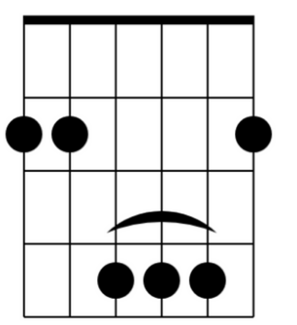
Carefree Highway Gordon Lightfoot

Capo 2

G F C Dsus4 D

G D B Em
Pickin up the pieces of my sweet shattered dream
C G Dsus4 D
I wonder how the old folks are tonight
G D B Em
Her name was Ann and I'll be damned if I recall her face
C D G
She left me not knowing what to do

Chorus
G F C D G
Carefree highway let me slip away on you
F C D
Carefree highway you've seen better days
Em D C A (stop)
The morning after blues from my head down to my shoes
G F C D G
Carefree highway let me slip away slip away on you

F C D G F C Dsus4 D

G D B Em
Turning back the pages to the times I love best
C G Dsus4 D
I wonder if she'll ever do the same
G D B Em
Now the thing that I call living is just being satisfied
C D G
With knowing I got no one left to blame

Chorus
G F C D G
Carefree highway let me slip away on you
F C D
Carefree highway you've seen better days
Em D C A
The morning after blues from my head down to my shoes
G F C D G
Carefree highway let me slip away slip away on you

F C D G F C Dsus4 D

G D B Em
Searching thru the fragments of my dream shattered sleep
C G Dsus4 D
I wonder if the years have closed her mind
G D B Em
Well I guess it must be wander lust or trying to get free
C D G
From the good old faithful feeling we once knew

Chorus
G F C D G
Carefree highway let me slip away on you
F C D
Carefree highway you've seen better days
Em D C A
The morning after blues from my head down to my shoes
G F C D G
Carefree highway let me slip away slip away on you
D G
Let me slip away on you

F C D G
Carefree highway I got to see you my old flame
F C D
Carefree highway you've seen better days
Em D C A
The morning after blues from my head down to my shoes
G F C D G
Carefree highway let me slip away slip away on you

F C D G F C D 2x

G

