CHELSEA MORNING Joni Mitchell capo 4

G (folk)
Woke up, it was a Chelsea morning

and the first thing that I heard
C G
Was a song outside my window
C G
and the traffic wrote the words
C G
It came ringing up like Christmas bells
C D11 D11
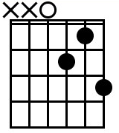
and rapping up like pipes and drums
G
Oh won't you stay?

We'll put on the day
C G
And we'll wear it 'till the night comes

G
Woke up it was a Chelsea morning

and the first thing that I saw
C G
Was the sun through yellow curtains
C G
and a rainbow on the wall
C G
Blue red green and gold to welcome you
C D11
crimson crystal beads to beckon
G
Oh won't you stay?

We'll put on the day
C G
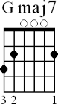
There's a sun show every second

---------------------
CHORUS

C G D11 G
Now the curtain opens on a portrait of today
C GMaj7
And the streets are paved with passersby
C
And pigeons fly
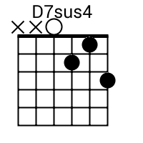
And papers lie
D7sus
Waiting to blow away

---------------------

G
Woke up it was a Chelsea morning

and the first thing that I knew
C G
There was milk and toast and honey
C G
and a bowl of oranges too
C G
And the sun poured in like butterscotch
C D11
and stuck to all my senses
G
Oh won't you stay?

We'll put on the day
C G
And we'll talk in present tenses

---------------------
CHORUS

C G D11 G
When the curtain closes and the rainbow runs away
C GMaj7
I will bring you incense owls by night
C
By candlelight by jewel-light
D7sus
If only you will stay

Pretty baby won't you
G
Wake up it's a Chelsea morning

