Cinnamon Girl Neil Young capo 2

D Am
I wanna live with a cinnamon girl
C G
I could be happy the rest of my life
F G C D
With a cinnamon girl

D Am
A dreamer of pictures I run in the night
C G
You see us together, chasing the moonlight
F G C D
My cinnamon girl

D Am
Ten silver saxes, a bass with a bow
C G
The drummer relaxes and waits between shows
F G C D
For his cinnamon girl

D Am
A dreamer of pictures I run in the night
C G
You see us together, chasing the moonlight
F G C D
My cinnamon girl

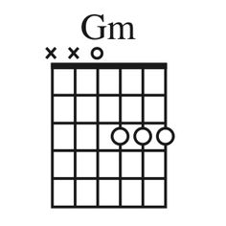
C
Pa sent me money now

I'm gonna make it somehow
Gm
I need another chance
Am
You see your baby loves to dance
D
Yeah...yeah...yeah...yeah

