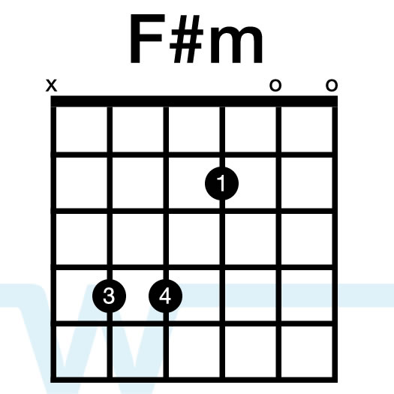
The Circle Game Joni Mitchell

A D A
Yesterday a child came out to wonder
A D E
Caught a dragonfly inside a jar
A D F#m
Fearful when the sky was full of thunder
D A E A
And tearful at the falling of a star
--------------------
A D A
Then the child moved ten times 'round the seasons
A D E
Skated over ten clear frozen streams
A D F#m
Words like, when you're older, must appease him
D A E A
And promises of someday make his dreams
--------------------
CHORUS:
A E A
And the seasons, they go 'round and 'round
A E A
And the painted ponies go up and down
D A
We're captive on a carousel of time
D F#m D
We can't return, we can only look behind from where we came
D F#m D E A
And go 'round and 'round and 'round in the circle game
--------------------
A D A
Sixteen springs and sixteen summers gone now
A D E
Cartwheels turn to car wheels through the town
A D F#m
And they tell him, take your time it won't be long now
D A E A
'Till you drag your feet to slow the circles down
--------------------
CHORUS
--------------------
A D A
So the years spin by and now the boy is twenty
A D E
Though his dreams have lost some grandeur coming true
A D F#m
There'll be new dreams, maybe better dreams and plenty
D A E A
Before the last revolving year is through
--------------------
CHORUS, TAG

