Comes A Time Neil Young

[Verse 1]

G Bm
Comes a time, when you’re driftin’
D Am7 C
Comes a time, when you settle down
G Bm
Comes a light, feelin’s liftin’
D Am7 C
Lift that baby right up off the ground

[Chorus]

G F C G
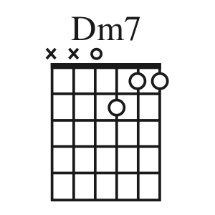
Oh ... this old world keeps spinnin’ ‘round
F C G
It’s a wonder tall trees ain’t layin’ down
Dm7
There comes a time

[Verse 2]

G Bm
You and I, we were captured
D Am7 C
We took our souls, and we flew away
G Bm
We were right, we were giving
D Am7 C
That’s how we kept what we gave a-way

[Chorus]

G F C G
Oh ... this old world keeps spinnin’ ‘round
F C G
It’s a wonder tall trees ain’t layin’ down
Dm7
There comes a time

