Diamonds and Rust Joan Baez

Em
Well I'll be damned
C
Here comes your ghost again
G
But that's not unusual
D
It's just that the moon is full
Em
And you happened to call

Em
And here I sit
C
Hand on the telephone
G
Hearing a voice I'd known
D
A couple of light years ago
Em
Heading straight for a fall

Em
As I remember your eyes
C
Were bluer than robin's eggs
G
My poetry was lousy you said
D
Where are you calling from?
Em
A booth in the Midwest

Em
Ten years ago
C
I bought you some cufflinks
G
You brought me something
D
We both know what memories can bring
Em
They bring diamonds and rust

Em
Well you burst on the scene
C
Already a legend
G
The unwashed phenomenon
D
The original vagabond
Em
You strayed into my arms

Em
And there you stayed
C
Temporarily lost at sea
G
The Madonna was yours for free
D
Yes the girl on the half-shell
Em
Would keep you unharmed

Bm
Now I see you standing

With brown leaves falling around
Am
And snow in your hair
Bm
Now you're smiling out the window

Of that crummy hotel
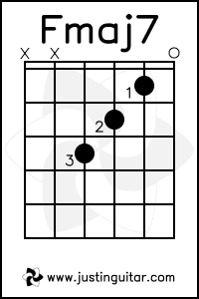
Am
Over Washington Square
C
Our breath comes out white clouds
G
Mingles and hangs in the air
Fmaj7
Speaking strictly for me
G B7
We both could have died then and there

Em
Now you're telling me
C
You're not nostalgic
G
Then give me another word for it
D
You who are so good with words
Em
And at keeping things vague

Em
Because I need some of that vagueness now
C
It's all come back too clearly
G
Yes I loved you dearly
D
And if you're offering me diamonds and rust
Em
I've already paid

