EAGLES: THE GIRL FROM YESTERDAY (Frey/Tempchin) (100 – 4/4)

Capo 2 All chords 4 beats unless noted

[Verse 1]
C(3) G D G D

[Verse 1]

G G7 C(8)
It wasn't really sad the way they said goodbye

D D7 G D
or maybe it just hurt so bad she couldn't cry

G G7 C(8)
he packed his things walked out the door and drove away

G D G D
and she became the girl from yester-day

[Verse 2]

G G7 C(8)
He took a plane a-cross the sea to some foreign land

D D7 G D
she stayed at home and tried so hard to understand

G G7 C(8)
how someone who had been so close could be so far a-way

G D G(8)
and she became the girl from yester-day

[Chorus]

D(8) C G
She doesn't know what's right, she doesn't know what’s wrong

G(2) D(2) Em7(2) D(2) C D
she only knows the pain that comes from waiting for so long

C G C G
and she doesn't count the teardrops that she's cried while he's a-way

Em(2) D(2) C(2) G(2)
be-cause she knows deep in her heart

Am7(2) A7(2) D7sus4 D
that he'll be back someday

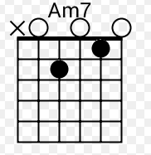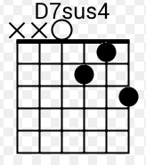

[Solo]

G G7 C C
G D G E

[Verse 3]

A A7 D(8)
The light's on in the window, she's waiting by the phone

E(8) A E
talking to a memory that's never coming home

A A7
she dreams of his returning

D(8)
and the things that he might say

A E A D
but she’ll always be the girl from yester-day

A E D A(1)
yeah she'll always be the girl from yester-day...

