Goin Back chords
The Byrds (Carole King/Gerry Goffin)

G Gsus4 G 2x

G C G Gsus4 G
I think I'm going back to the things I learned so well in my youth
C
I think I'm returning to those days when I was young enough
G Gsus4 G
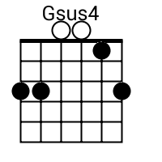
to know the truth
Em Bm
Now there are no games, to only pass the time
Em G
No more electric trains, no more trees to climb
C D7 G
But thinking young and growing older is no sin;
C D7 G Gsus4 G
and I can play the game of life to win

G C G Gsus4 G
I can recall a time when I wasn't ashamed to reach out to a friend
C G Gsus4 G
Now I think I've got a lot more than just my toys to lend
Em Bm
Now there's more to do than watch my sailboat glide
Em G
But every day can be a magic carpet ride
C D7 G Gsus4 G
A little bit of courage is all we lack
C D7 G Gsus4 G
so catch me if you can, I'm going back

C D7 G Gsus4 G
La la la la la la la la la la la
C D7 G Gsus4 G
La la la la la la la la la

Em Bm
Now there's more to do than watch my sailboat glide
Em G
But every day can be a magic carpet ride
C D7 G Gsus4 G
A little bit of courage is all we lack
C D7 G Gsus4 G
so catch me if you can, I'm going back

C D7 G Gsus4 G
La la la la la la la la la la la
C D7 G Gsus4 G
La la la la la la la la la

