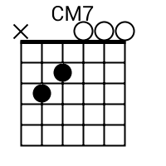
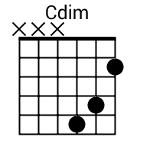
Hello Dolly by Louis Armstrong Capo 2

C Am
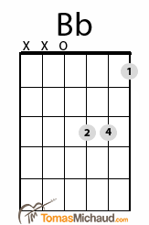
I said hel - lo dolly well hel - lo Dolly
CM7 (Cdim) G7
It's so nice to have you back where you belong
Dm Bb
You're lookin' swell Dolly I can tell Dolly
Dm G7
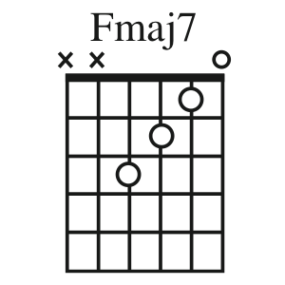
You're still glowin' you're still crowin'
C (Cdim) G7
you're still go - in' strong (comin’ thru)
C Am
I feel that room swayin' while the band's playin'
(Gm7) C7 FM7
one of your old favorite songs from way back when
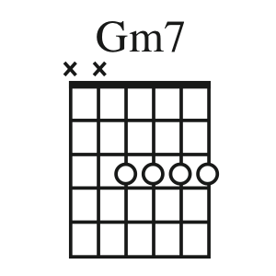
E7 Am Em Am Em
So take her wrap fellas find her an empty lap fellas
D7 G7 C (Cdim) G7
Dolly'll never go away again

[Verse 2]
C Am
I said hel - lo dolly well hel - lo Dolly
CM7 (Cdim) G7
It's so nice to have you back where you belong
Dm Bb
You're lookin' swell Dolly I can tell Dolly
Dm G7
You're still glowin' you're still crowin' you're
C (Cdim) G7
still go - in' strong
C Am
I feel that room swayin' while the band's playin'
(Gm7) C7 FM7
one of your old favorite songs from way back when
E7 Am Em Am Em
So golly gee fellas find her an empty knee fellas
D7 G7 D7 G7
Dolly'll never go away I said she'll never go away
D7 G7 C
Dolly'll never go away again

