One U2

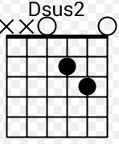
Am Dsus2
Is it getting better
Fmaj7 G
Or do you feel the same
Am Dsus2
Will it make it easier on you now
Fmaj7 G
you've got someone to blame
C Am
you say one love one life
Fmaj7 C
when it’s one need in the night
C Am
one love we get to share it
Fmaj7 C Am Dsus2 Fmaj7 G
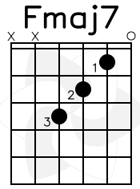
it leaves you baby if you don’t care for it
----------------------------

Am Dsus2
Did I disappoint you
Fmaj7 G
Or leave a bad taste in your mouth
Am Dsus2
You act like you never had love
Fmaj7 G
and you want me to go without
C Am
Well it's too late tonight
Fmaj7 C
to drag the past out into the light
C Am
We're one, but we're not the same
Fmaj7 C
We get to carry each other carry each other
Am Dsus2 Fmaj7 G
one
----------------------------

Am Dsus2
Have you come here for forgiveness?
Fmaj7 G
Have you come to raise the dead?
Am Dsus2
Have you come here to play Jesus
Fmaj7 G
To the lepers in your head?

C Am
Did I ask too much more than a lot
Fmaj7 C
You gave me nothing now it's all I got
Am
We're one but we're not the same
Fmaj7 C
Well we hurt each other then we do it again

C Am
You Say Love is a temple, Love a higher law
C Am
Love is a temple, Love the higher law
C G
You ask me to enter, but then you make me crawl
G Fmaj7
And I can't be holding on to what you got
Fmaj7 C Am
When all you got is hurt one love one blood
Fmaj7 C
One life you got to do what you should
Am Fmaj7 C
One life with each other Sisters brothers
Am
One life but we're not the same
Fmaj7 C
We get to carry each other carry each other
C Am Fmaj7 C
One

