Sweet Caroline Neil Diamond

E7 E7\E E\E7 E E7 A

-----------------
A D
Where it began I can’t begin to knowin’
A E
But then I know it’s growin’ strong
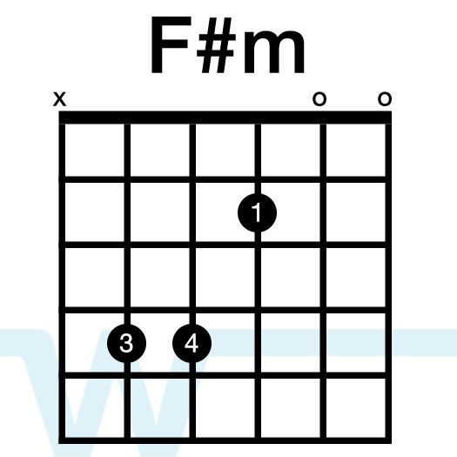
A D
Was in the spring and spring became the summer
A E E7
Who’d have believed you’d come along

A F#m
Hands touching hands
E D E E D E
Reachin’ out touchin’ me touchin’ you

-----------------

A D D A D E E D E

Sweet Caroline good times never seemed so good
A D D A D E
I’ve been inclined to believe they never would
D C#m Bm
But now I

-----------------

A D
Look at the night and it don’t seem so lonely
A E
We fill it up with only two
A D
And when I hurt hurtin’ runs off my shoulders
A E E7
How can I hurt when holdin’ you

A F#m
Warm touchin’ warm
E D E E D E
Reachin’ out touchin’ me touchin’ you

-----------------

A D D A D E E D E
Sweet Caroline good times never seemed so good
A D D A D E
I’ve been inclined to believe they never would
D C#m Bm
Oh no no

-----------------

E7 E7\E E\E7 E E7 A

-----------------
A D D A D E E D E
Sweet Caroline good times never seemed so good
A D D A D E
Sweet Caroline I believed they never could
A D D A D E E D E
Sweet Caroline good times never seemed so good
A D D A D E
Sweet Caroline I believed they never could

