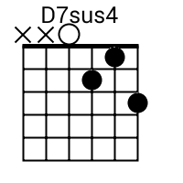
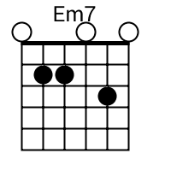
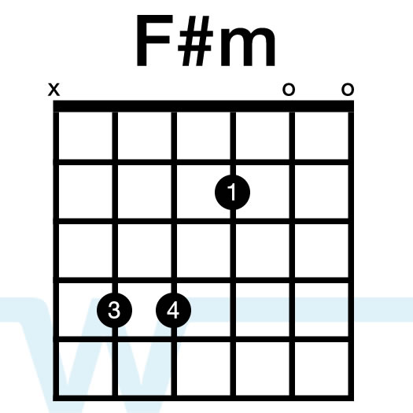
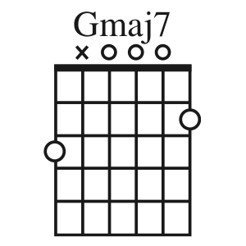
You’ve Got a Friend

Use Folk G throughout song

[Verse 1]

Em B7 Em B7 Em(7)
When you're down and troubled and you need a helping hand
Am7 D7sus4 G
and nothing, oh, nothing is going right
Em B7 Em B7 Em
close your eyes and think of me and soon I will be there
Am7 Bm7 D7sus4 /D7
to brighten up even your darkest night (Bm7 = B7 w/o first finger)

[Chorus]

G Gmaj7 C Am7
You just call out my name, and you know wherever I am
G Gmaj7 D7sus4 D7
I'll come running to see you again
G Gmaj7 C Em
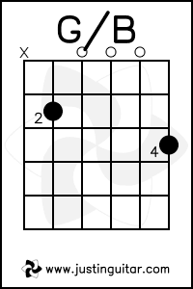
Winter, spring, summer, or fall, all you got to do is call
C G/B D7sus4
and I'll be there, yeah, yeah, yeah
G
You've got a friend

[Verse 2]

Em B7 Em B7 Em(7)
If the sky above you should turn dark and full of clouds
Am7 D7sus4 G
and that old north wind should begin to blow
Em B7 Em B7 Em
keep your head together and call my name out loud
Am7 Bm7 D7sus4 D7
Soon I'll be knocking upon your door

[Bridge]

F C
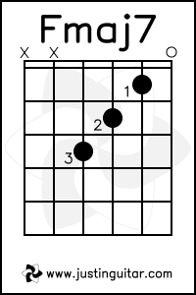
Hey ain't it good to know that you've got a friend when
G Gmaj7 C Fmaj7
people can be so cold They'll hurt you and desert you
Bm7 A7
Well, they'll take your soul if you let them
D7sus4 D7
Oh yeah, but don't you let them

[Chorus]

C G
Ain't it good to know you've got a friend
C G
Ain't it good to know you've got a friend
C G
Oh, yeah, yeah. You've got a friend

