Donovan-Gras Family Tree

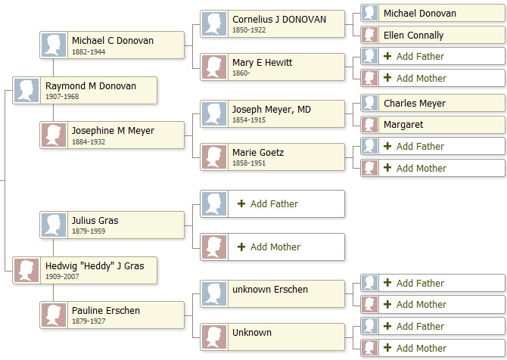

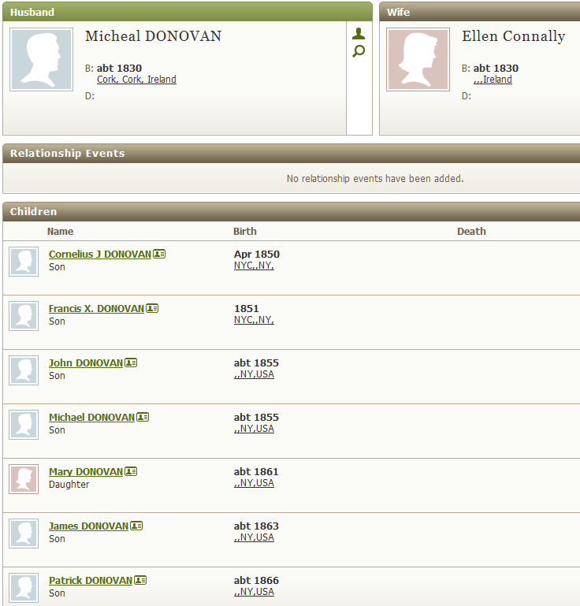
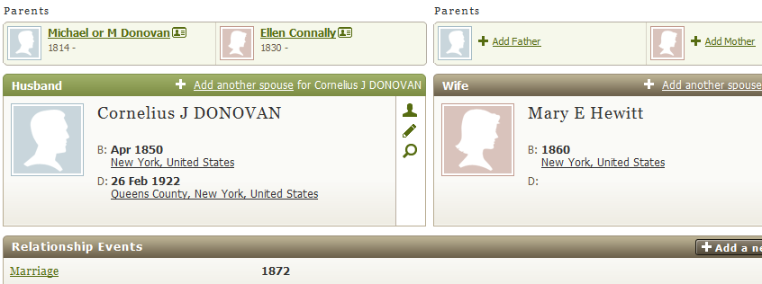

Children on next page
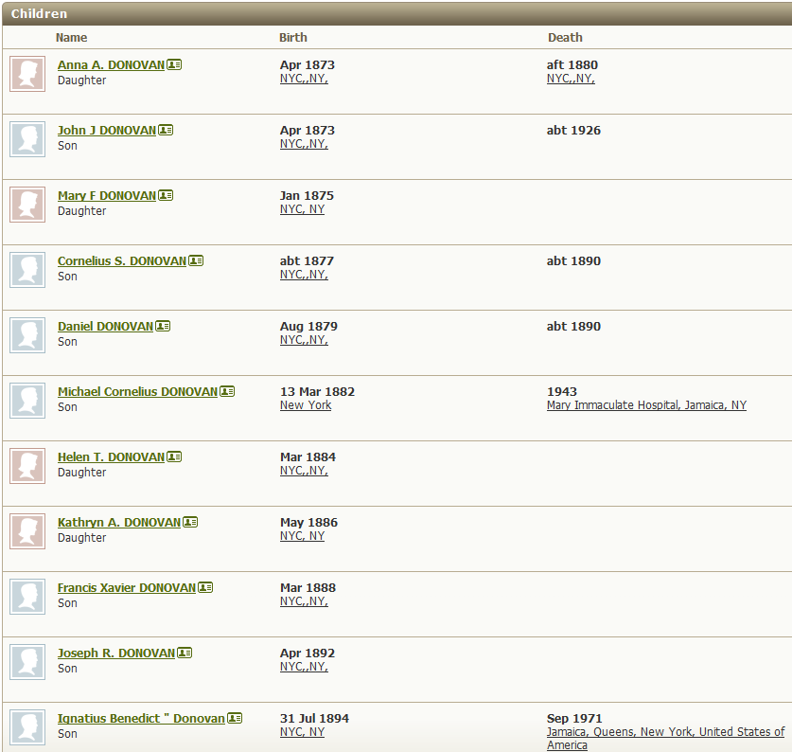

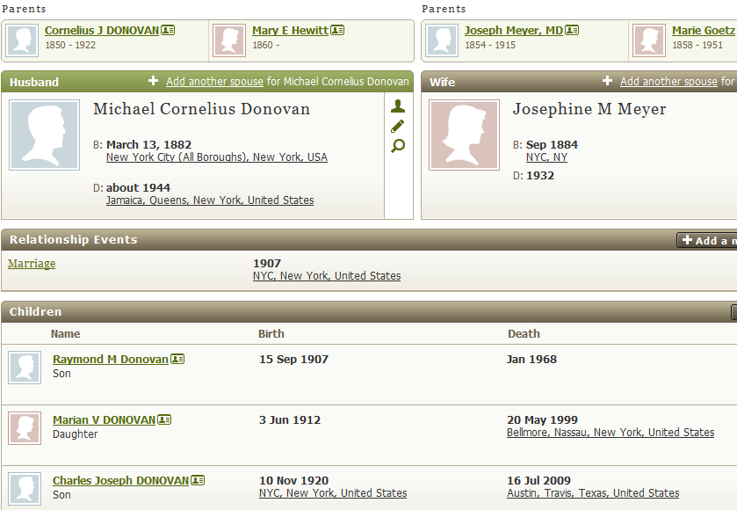

Michael Cornelius DONOVAN
Died in Mary Immaculate Hospital, Jamaica, NY
Married at age 25

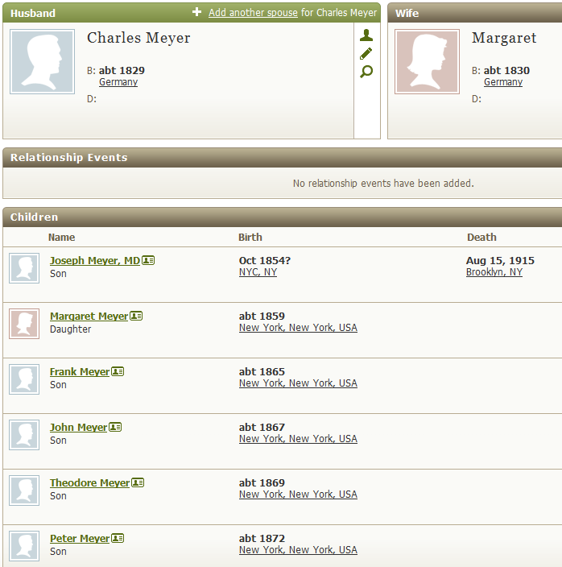
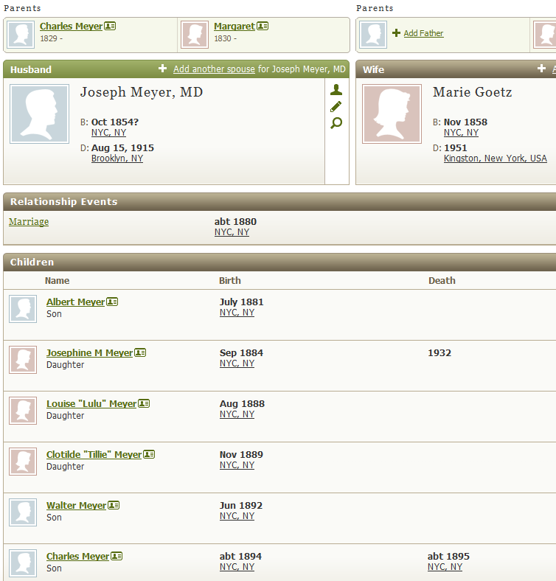
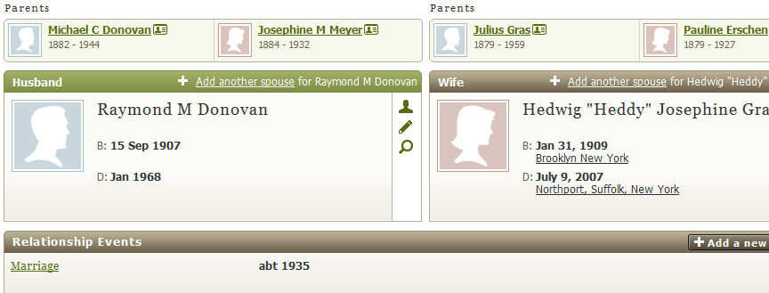

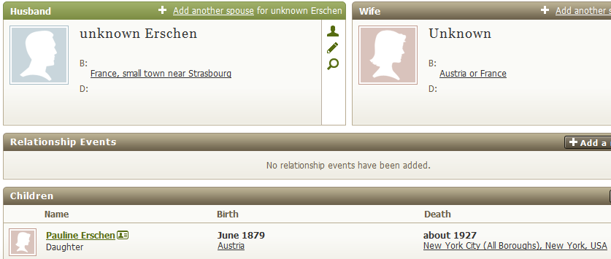

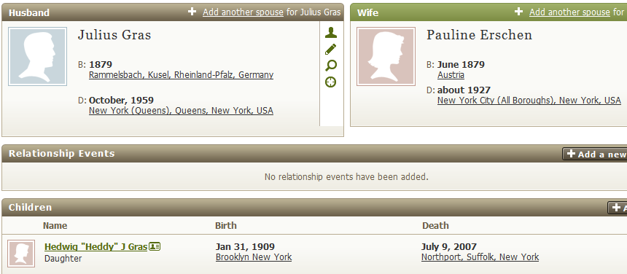

As of 1900 census:
Pauline Erschen was 20, single, working as a servant, birthday June 1879

As of 1910 census:
Julius Gras was 31; he immigrated in 1898; he was an unemployed iron moulder/foundry worker – he’d been unemployed for 25 weeks
Pauline was 31; she immigrated in 1895
They had been married 7 years

Raymond Donovan
United States Census, 1910
birth: 1908 —New York (mom says Richmond Hill)
residence: 1910 —Queens Ward 4, Queens, New York
parents: Michael C Donovan, Josephine Donovan

United States Census, 1930 for Raymond M Donovan
Name: | Raymond M Donovan
Event: | Census
Event Date: | 1930
Event Place: | Queens (Districts 0251-0500), Queens, New York
Gender: | Male
Age: | 22
Marital Status: | Single
Race: | White
Birthplace: | New York
Estimated Birth Year: | 1908
Immigration Year:
Relationship to Head of Household: | Son
Father's Birthplace: | New York
Mother's Birthplace: | New York
Enumeration District Number: | 0322
Family Number: | 217
Sheet Number and Letter: | 13A
Line Number: | 9
NARA Publication: | T626, roll 1597
Film Number: | 2341332
Digital Folder Number: | 4639146
Image Number: | 00347
 | Household | Gender | Age
Parent | Michael E Donovan (E should be C) | M | 47
Parent | Josephine M Donovan | F | 45
 | Raymond M Donovan | M | 22
 | Marion V Donovan | F | 17
 | Charles J Donovan | M | 9

United States Census, 1930 for Michael E Donovan (E should be C)
Name: | Michael E Donovan (E should be C)
Event: | Census
Event Date: | 1930
Event Place: | Queens (Districts 0251-0500), Queens, New York
Gender: | Male
Age: | 47
Marital Status: | Married
Race: | White
Birthplace: | New York
Estimated Birth Year: | 1883
Immigration Year:
Relationship to Head of Household: | Head
Father's Birthplace: | New York
Mother's Birthplace: | New York
Enumeration District Number: | 0322
Family Number: | 217
Sheet Number and Letter: | 13A
Line Number: | 7
NARA Publication: | T626, roll 1597
Film Number: | 2341332
Digital Folder Number: | 4639146
Image Number: | 00347
 | Household | Gender | Age
 | Michael E Donovan (E should be C) | M | 47
Spouse | Josephine M Donovan | F | 45
Child | Raymond M Donovan | M | 22
Child | Marion V Donovan | F | 17
Child | Charles J Donovan | M | 9

United States Census, 1930 for Josephine M Donovan
Name: | Josephine M Donovan
Event: | Census
Event Date: | 1930
Event Place: | Queens (Districts 0251-0500), Queens, New York
Gender: | Female
Age: | 45
Marital Status: | Married
Race: | White
Birthplace: | New York
Estimated Birth Year: | 1885
Immigration Year:
Relationship to Head of Household: | Wife
Father's Birthplace: | New York
Mother's Birthplace: | New York
Enumeration District Number: | 0322
Family Number: | 217
Sheet Number and Letter: | 13A
Line Number: | 8
NARA Publication: | T626, roll 1597
Film Number: | 2341332
Digital Folder Number: | 4639146
Image Number: | 00347
 | Household | Gender | Age
Spouse | Michael E Donovan (E should be C) | M | 47
 | Josephine M Donovan | F | 45
Child | Raymond M Donovan | M | 22
Child | Marion V Donovan | F | 17
Child | Charles J Donovan | M | 9

